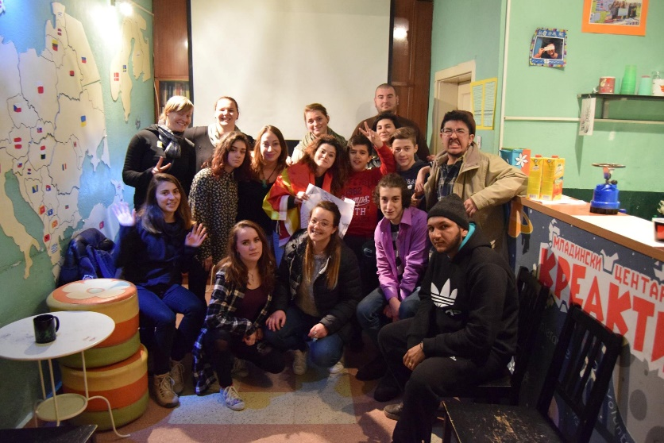 | Volunteer with youth and children  _______  Non-formal education  _______  PEACE EDUCATION & COMMUNITY ACTIVISM  _______  ENVIRONMENT & HEALTH  _______  art & media
EVS in Youth Association creACTive

Kavadarci, Republic of Macedonia
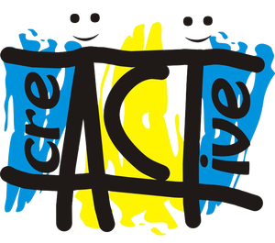 | Youth Association Kreaktiv Kavadarci  Ul. Ilindenska 119  1430 Kavadarci  Republic of Macedonia  www.kreaktiv.mk  kontakt@kreaktiv.mk  Facebook page: Youth Association Kreaktiv

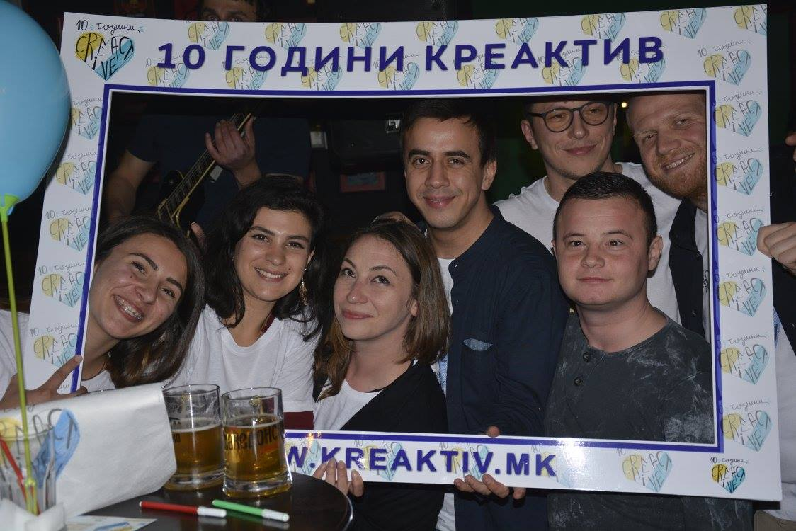
creACTive is a youth association founded to support creativity and active citizenship of young people in Kavadarci. It was created in 2007 by Dragan Markoski and Dragan Atanasov and its main aim is to assist the personal development of young people through their engagement in non-formal educational activities.

creACTive implements various youth projects, on both local and international levels. While the local activities range from workshops, volunteer actions, seminars, and sport competitions to various performances and other events, creACTive’s international work includes youth exchanges and training courses organized in Macedonia and in other countries, mainly in the framework of the ERASMUS+ programme of the European Commission, and EVS projects.
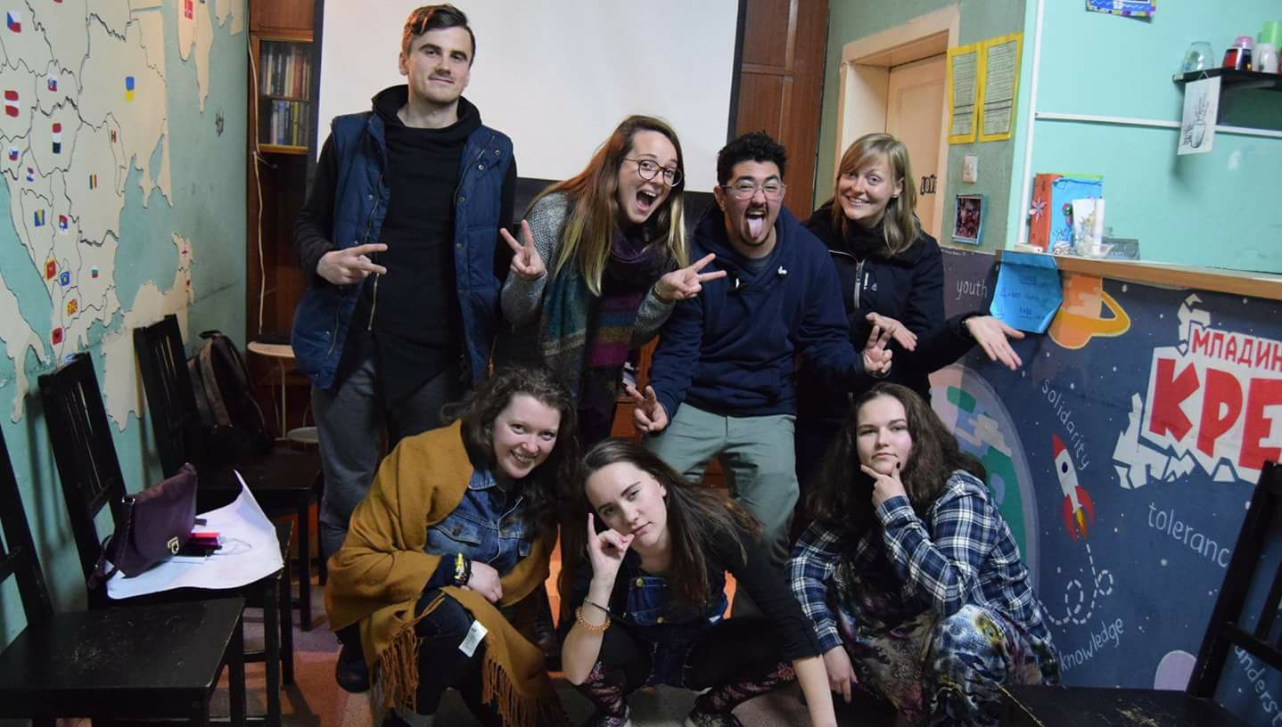
The work of creACTive is devoted solely to young people; it is based on the principles of non-formal education, learning-by-experience, and intercultural learning. The organization is led by a diverse team of young people and experienced youth workers.

creACTive contributes to the development of civil society in Macedonia, with a special emphasis on young people’s place in the social events and processes. We expect that the activities of creACTive will result in the development of creative young people involved in the process of decision-making in their local communities.

Everyday Activities
creACTive empowers youth and supports their personal and professional development by promoting peace, tolerance, creativity, and active citizenship through non-formal learning methods. Our work is divided into three main areas of action:

Peace education and community activism: To build personal and social identity for a stronger and more inclusive society.

Environment and health: to raise ecological awareness, and advocate for sustainable and healthy living.

Art and media: To explore emotional intelligence through creative self-expression.
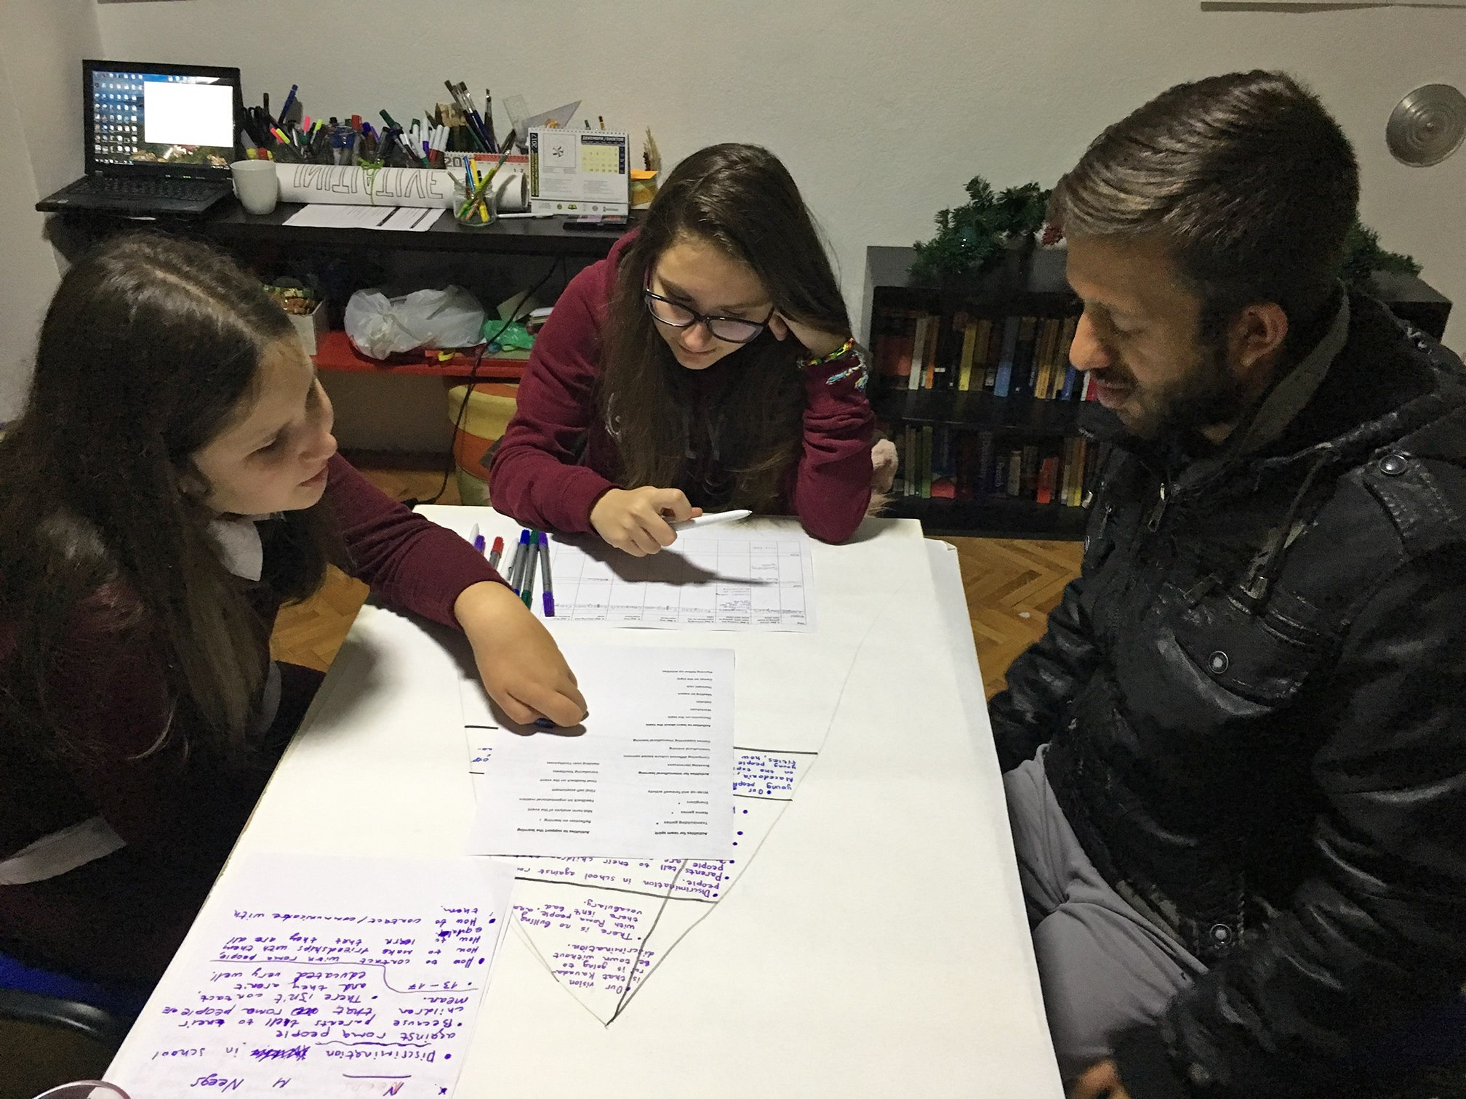
creACTive is open from Monday till Friday, from 12:00 to 18:00, for the youngsters of Kavadarci to come and take part in various workshops, clubs, and trainings. We have offered language classes, creative workshops, professional development trainings, and educational clubs such as a Writing club, Theatre club, film/photography club, Creactive lab club, Enviormental Club, Animal Protection Club and Human rights club, among others. Volunteers are welcome to create their own plans for ongoing non-formal educational programs within Kreaktiv.

We also take part in various community projects, such as volunteering weekly at the city’s Daily Center for Adults with Disabilities, running a campaign for sexual health, assisting with a youth-led local movie festival, organizing football games for local youngsters, and more. We encourage volunteers to think outside the box and come up with their own ideas for community initiatives.

Outdoor Activities
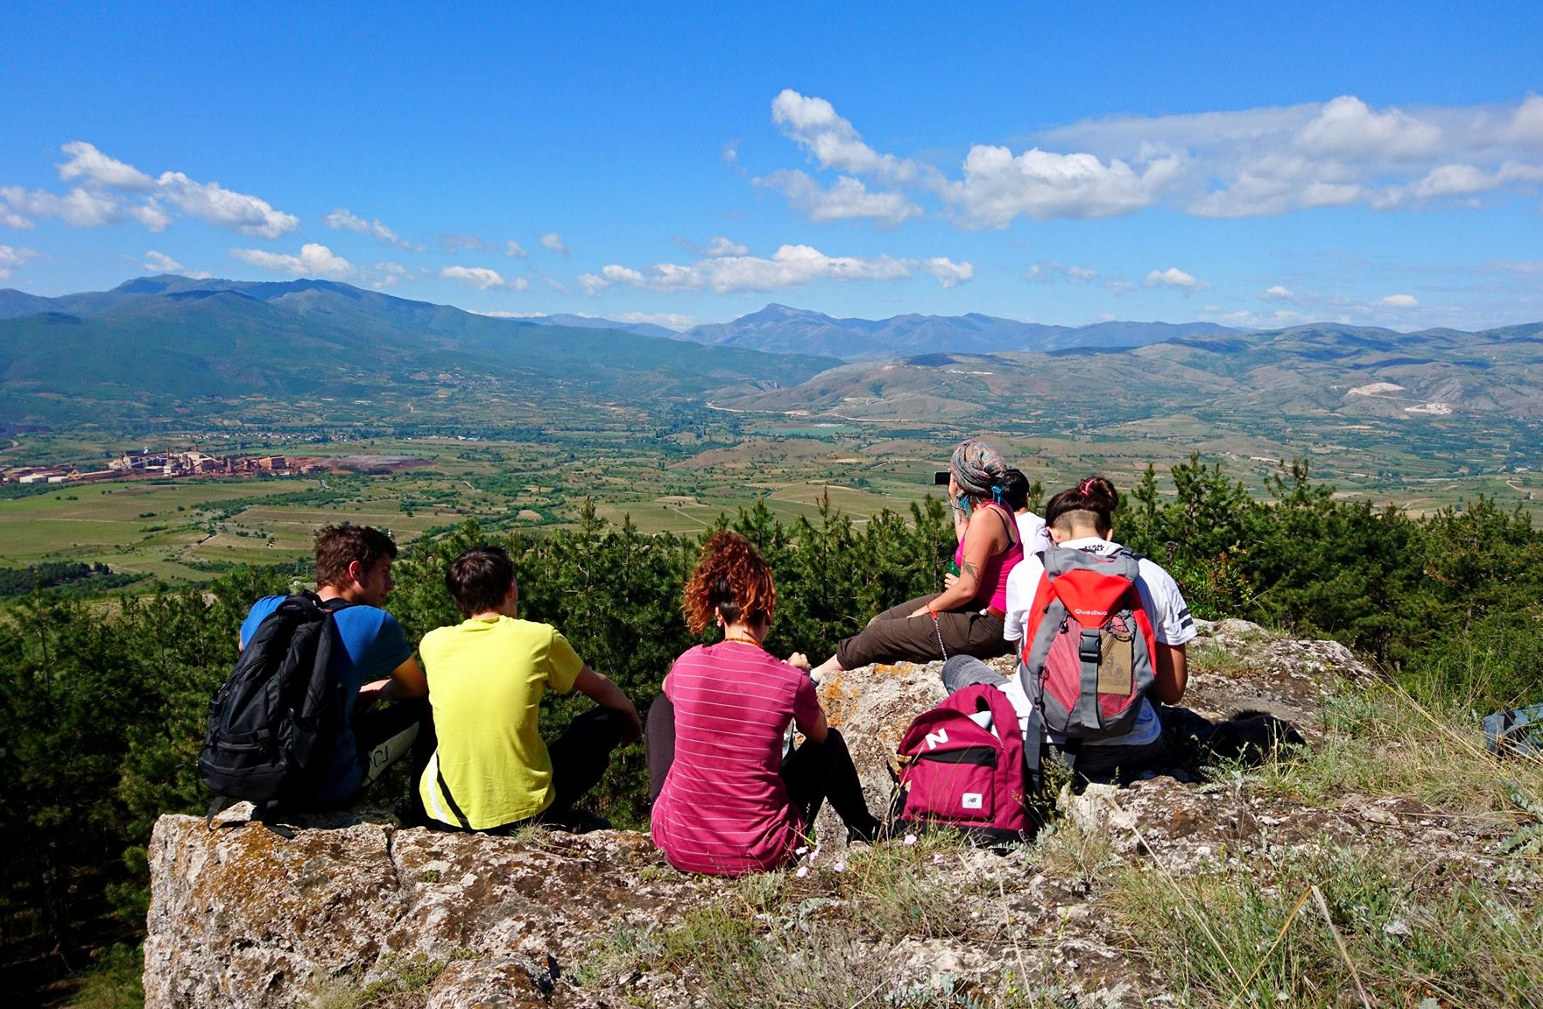
Besides the regular every day activities at creACTive, EVS volunteers can initiate different sport and outdoor activities according to their interests and skills. For the past year we have run a twice-monthly hiking club for youngsters to gain experiences of the outdoors, to relieve stress by engaging with nature, and to learn more about the greater area of Kavadarci.

Summer Camp
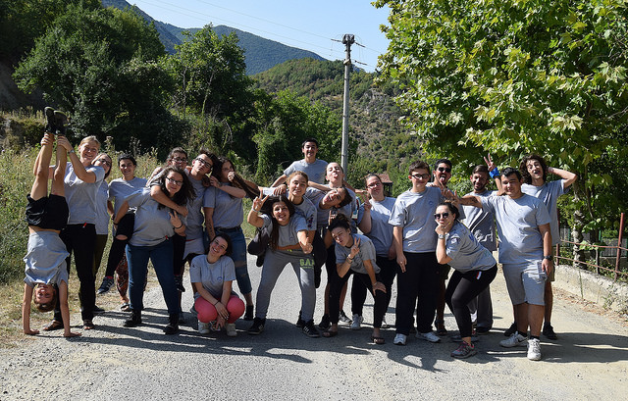
Every summer, Kreaktiv organises a Summer Camp for teenagers between 14 and 18 years old. The youngsters learn about equality, leadership, social and communication skills, professional development, and active citizenship. The EVS volunteers can lead and implement the activities with the assistance of the youth workers of creACTive.

CLUBS
Clubs are gathering every week once, lead by the young people that participate in it. Every EVS has an opportunity to chose which club he will take to lead, help and facilitate the young people to do the projects they are planning to do.
But also the volunteer can chose to form and develop a new club, depending on their skills, knowledge and passion.
Present clubs:
Theatre Club
Film/Photography Club
Animal Protection Club
Environmental Club
Youth Club
Human rights Club
Science Lab Club
Writing Club

Republic of Macedonia

Macedonia is a country situated in the Balkans. Its capital city is Skopje and the official language is Macedonian. In some parts of the country, Albanian is also spoken.

The currency is the Macedonian denar (MKD). 1€ = 61MKD

The City of Kavadarci
Kavadarci is a town of about 40,000 inhabitants in the Tikvesh region of the Republic of Macedonia. It’s situated in the heart of Macedonia and the home to the largest winery in southeastern Europe - “TIKVESH”.

Situated near Kavadarci is Macedonia's largest artificial lake, Lake Tikvesh. The town is known for its wine and rakija, a typical drink made from grapes. Here you can enjoy both city life and the quiet natural surroundings

A Few Words in Macedonian
English | Standard Macedonian
Hello | Здраво (Zdravo)
How are you? | Како си? (Kako si?)
What is your name? | Како се викаш? (Kako se vikaš)
My name is…. | Јас се викам ... (Jas se vikam ...)
Where are you from? | Од каде си? (Od kade si?)
I’m from… | Јас сум од (Jas sum od ...)
Goodbye | Пријатно (Prijatno)
Cheers | На здравје (Na zdravie)
I don’t understand | Не разбирам (Ne razbiram)
Do you understand English? | Дали разбираш англиски? (Dali razbiraš anglisky?)
Sorry/ Excuse me | Извини (Izvini)
Thank you | Фала (Fala)
Please | Ве молам (Ve molam)
Good | Добро (Dobro)
Yes | Да (Da)
No | Не (Ne)

SEE YOU IN creACTive! | Team Contacts
SEE YOU IN creACTive! | George Lazov – Coordinator  lazov@kreaktiv.mk
SEE YOU IN creACTive! | Dragan Markoski – Manager of Youth Association creACTive  markoski@kreaktiv.mk
SEE YOU IN creACTive! | Jordan Nikolovski – Financial Manager  orce@kreaktiv.mk  Sam Mintz – Peace Corps Volunteer
SEE YOU IN creACTive! | sam@kreaktiv.mk

