Infopack UNA CHANCE PER TUTTI 2

Hosting Activity of Group EVS in the organization Link in Italy, Altamura.
Arrival date: 04 April 2016 Departure date: 03 May 2016

The month of EVS project will be based on the group dynamics which will be created through the participation of three Polish volunteers and three Macedonian volunteers, together with local Italian volunteers. Link wants to invite all volunteers in the support of the Mediaeval Festival “Federicus” which is organized for the 5th time in our city, Altamura. Our focus will be on the joy and happiness of children in using self-made wooden games, done by us!
Moreover the volunteers will have the chance to experience Italian lifestyle and learn basic Italian language.

The month will be structured in the following way:
1st week  04 April – 08 April | On- Arrival training:  - Get to know each other as person  - Get to know each other as “culture”  - Get to know the hosting city and environment, orientation in the city  - Learning about interculturality and problem solving  - Language training: Get to know Italian language (basic training of 6 hours)  - Project: Get to know the idea of the project and its activities, visit of project sites.  - Creation of a Learning Diary  - Learning about Youthpass and non-formal education  - Rules for living together  Optional weekend trips to visit the surroundings.
2nd week  11 April – 15 April | Preparations for the Festival  - learn more about the structure of the Festival and it’s organization;  - brainstorming about games in mediaeval time in different countries;  - start the construction of games (especially out of wood) for children;  Optional weekend trips to visit the surroundings.
3rd week  18 April – 22 April | Definitions for the Festival  - finish the games for children;  - make decorations for our space and stand;  - prepare costumes for ourselves for the Festival;  - help in the assembling and installations of various decorations in the city center;
23 April – 25 April | Participation in the Federicus Festival, Mediaeval Festival in the center of Altamura, this years’ topic is the superstitions of the mediaeval time, have a look here: http://www.federicus.it/  We will have the management of a game area, eventually we will also give our support in Info points (who has language skills) and stands of other associations.
4th week  26 April – 02 May | After the Festival  - cleaning of the space;  - putting materials in order, with instructions of each game, for future use;  - relax after the Festival;  The last days will be used for reflection moments, evaluation of our work, journalism work on the Blog (selection of pictures, writing of testimonies, etc.) and final session of evaluation with the support of the Learning Diary, together with the compilation of Youthpass and ideas about Follow up.

The staff of this project will be:
Birgit (27 years, Austrian, speaks German, Italian, English)
Staff of Link. Social Worker. Coordinator of the group work and On-Arrival Training.
Sante (29 years, Italian, speaks Italian, English, French)
Staff of Link. Social Worker. Coordinator of the Festival workshop. Responsible for Logistics.
Ilaria (31 years, Italian, speaks Italian and English)
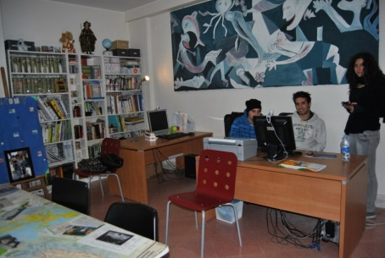
Staff of Link. Italian teacher.
Together with local volunteers and Link’s trainees who are going to be in the role of mentor and supporter of free time and personal regarding.

Hosting
The volunteers will be hosted in apartments in the city center, male and female divided. As soon we have the list of volunteers we will inform you about who will stay in which flat.
Flats have shared rooms, shared kitchen and living room and bathrooms. Each volunteer will be responsible for his own shopping, cleaning and caring for the house.

Pocket money and Food
The pocket money for 30 days of activity and 2 days of travel in Italy is 128€ per volunteer.
Food money for the whole month is 160€ per volunteer.
The volunteers will receive the money weekly, shared in four tranches.

Hosting city
Check out some information about Altamura on the internet: http://en.wikipedia.org/wiki/Altamura http://enjoyaltamura.com/
You can also see some information about our neighboring city Matera: http://en.wikipedia.org/wiki/Matera

Project Blog
The project is the follow up of the first edition of Una Chance per Tutti, where past volunteers created a Blog and wrote on it about their experiences around Europe. Have a look on the past stories and start to dream about your project: https://unachancepertutti.wordpress.com/
During the month each volunteer will be asked to write little reports and put pictures on the Blog to share his/her experience with friends, relatives and other youth who can be interested to participate to short-term projects.

