Responsible Youth = Healthy Future”
Youth exchange, Action 3.1 on
health and learning through sports and outdoor activities
Struga, Macedonia, 15-23 July 2013

INFO PACK
WHAT
Youth exchange “Responsible Youth = Healthy Future” concentrates on healthy lifestyles and learning through sports and outdoor activities.
WHY
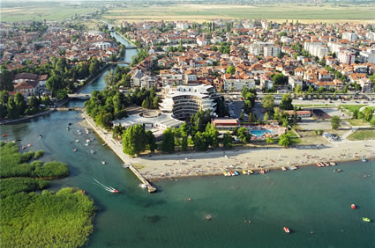
This project aims to promote young people to think more seriously about their health and lifestyle, analyze their habits in doing sports and moreover, to pay more attention on the situation of their friends and family. Partners of the project wish to promote a change of mentality among youth: to let the participants to realize that living in a healthy and responsible way is not an old-fashioned or something for strange outsiders. In addition, this project aims to motivate the participants to compare and contrast habits and cultures in Europe and develop an open-minded attitude towards the different.
HOW
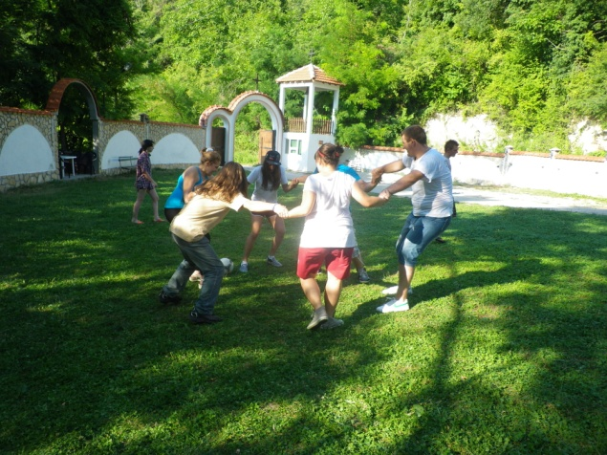
During this project several non-formal learning methods will be used. Discussions, debate, practical exercises, energizers, team-building activities, outdoor activities, public actions, flashmob etc are used to carry out the activities. Additionally, there will be cultural evenings to introduce for example the culture, traditions and food of participating countries and there is free time to get to know the project venue and beautiful city of Ohrid.

PARTICIPANTS
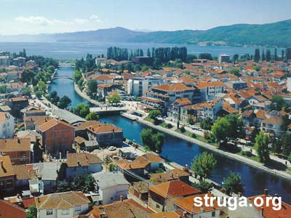
Young people age 18-26 from Estonia and Macedonia. 10 participants and 2 group leaders from both countries. Total number of participants: 24.
WHEN AND WHERE
This youth exchange will take place in Struga, Macedonia on 15-23 July 2013.
LANGUAGE
Youth exchange will be held in English.
FINANCE
This project is funded by Youth in Action Program and according to that 100% of accommodation, food and local transport and visa costs throughout the youth exchange and the 70% of the travel expenses are covered by the project.

More information: ngo.react@gmail.com

