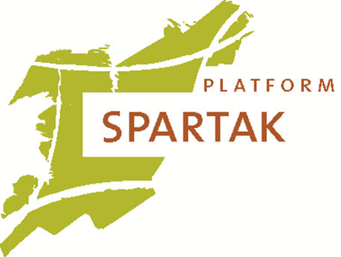
Call for Participants
European Express: A Balkan Journey Through
The World Of Freedom Of Speech

Summary
The youth exchange European Express: A Balkan Journey Through The World Of Freedom Of Speech will take place from the 5th of July until the 16th of July. We will start the exchange in Ljubljana, Slovenia. From there we will travel through Serbia to Skopje, Macedonia, the last city we will visit in this youth exchange. The project will involve 35 participants from Belgium, Bosnia, Macedonia, Romania, Serbia, Slovenia and The Netherlands.
The participants will explore the theme freedom of speech and its different sides, rights and obligations. They will do this in different settings, using their creative expressions in several ways.

Objectives
One of the main objectives of this project is to familiarize the participants with different levels of freedom of speech and the way it is connected to cultural and social backgrounds. Throughout the project the participants will be faced with the different realities on the Balkans, but also the realities within the countries of the other promoters. As the project starts in the EU member Slovenia the group will exchange the reality of the EU for the reality in Non-EU countries as Serbia and Macedonia. The Balkans are the most suitable for this, because of the recent Yugoslavian history and the problems it faced concerning the freedom of speech. The difference between EU and non-EU countries highlights that situations regarding freedom of speech should not be taken for granted, but are a result of a lot of effort. This will make the participants aware of their responsibility as citizens of the European community.
A second important objective of this project is to familiarize the participants with cultural diversity within the Europe. Besides the freedom of speech on a level of state and citizen, or state and media, the participants will also explore freedom of speech on a personal level. The manner in which people interact with family and friends is very much culturally bound, but also influenced by backgrounds. By discussing this topic and interacting with one another the participants will become aware of the challenges and opportunities that come with cultural diversity within a team and community.
A third objective is to stimulate the entrepreneurship and creativity of the participants. The participant will be given relative freedom in the start of a dialogue with the locals. They are also encouraged to take initiative in the creation of art forms they will use to create these dialogues. The group leaders will be there to facilitate the process and help the participants when needed.

Profile Participants
- Youngsters between the age of 18 and 25.
- Does not mind to travel by train and unexpected changes
- Affinity with the topic of Freedom of Speech
- Enjoys discussing issues in groups and likes to express him/herself in creative ways

Practical Information
- Before and after the exchange the participants will travel by train back to their homes. Please take this in consideration when checking your availability
- During the exchange we will also travel by train, however, we might encounter many delays and changes in the schedule, so please keep this in mind before you register.
- You will have to buy your train ticket or interrail to Brezice, Slovenia and back from Skopje, Macedonia yourself. However, 70% of the costs will be reimbursed afterwards.

Contact
Name organization
Adress + Postal code
Email:
Website:

